**Name: Rohan Ashok Ghanwat**

**Internship ID: UMIP273007**

**Topic : Human Resources Analyst(Business Analyst)**

**Human Resources Analyst Project Report**

**1. Introduction**

In this project, I have analyzed key Human Resources (HR) metrics using data visualization techniques in Tabula Desktop. The primary goal is to understand and visualize important aspects of the workforce, such as employee demographics, turnover rates, hiring trends, and performance metrics. The visualizations are intended to provide actionable insights that can help HR departments make informed decisions.

**2. Data Overview**

The dataset used for this project contains employee-related information, including demographics, turnover history, hiring trends, and performance data. The following HR metrics were analyzed:

* Employee Demographics: Age, gender, department distribution.
* Employee Turnover: Turnover rate, reasons for termination.
* Hiring Trends: Rate of new hires, sources of hire, and time to fill positions.
* Performance Metrics: Performance scores and identification of top performers.

*Note: The data used in this project is either sourced from the provided datasets by the company*

**3. Analysis and Visualizations**

**3.1 Employee Demographics**

* Gender Distribution:  
  A pie chart was created to visualize the gender breakdown of employees in the organization. This helps in understanding the gender balance.

*Screenshot of Gender Distribution Pie Chart*  
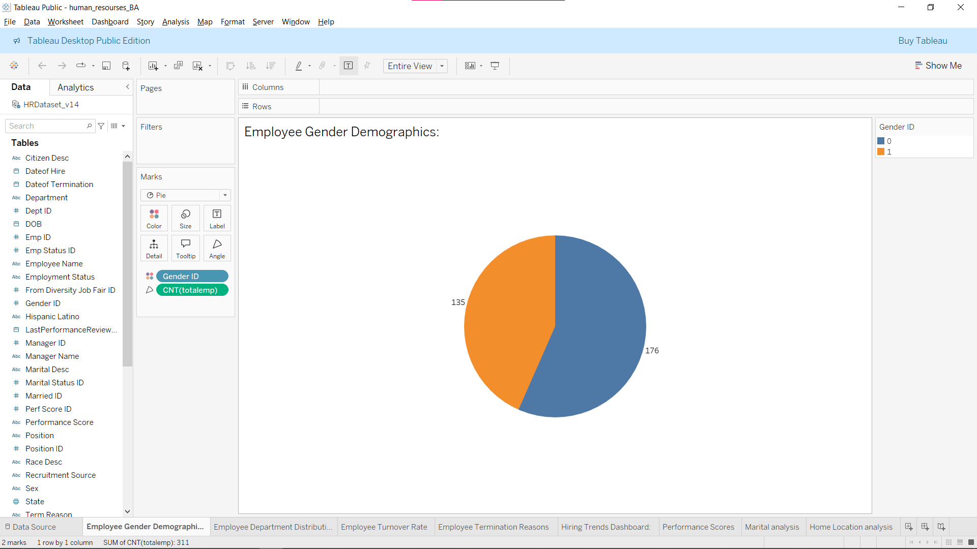

* Department Distribution:  
  A bar chart was used to show the number of employees in each department, helping to visualize the staffing structure.

*Screenshot of Department Distribution Bar Chart*  
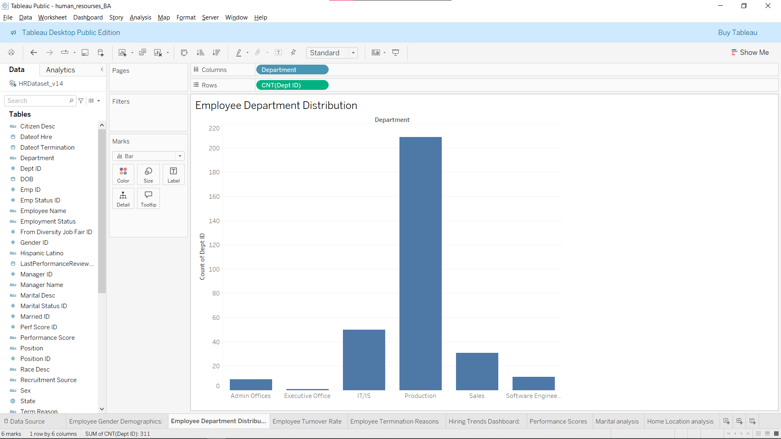

**3.2 Employee Turnover**

* Turnover Rate:  
  A line chart displays the turnover rate over a specific period. This helps to identify trends and seasonality in employee departures.

*Screenshot of Turnover Rate Line Chart*  
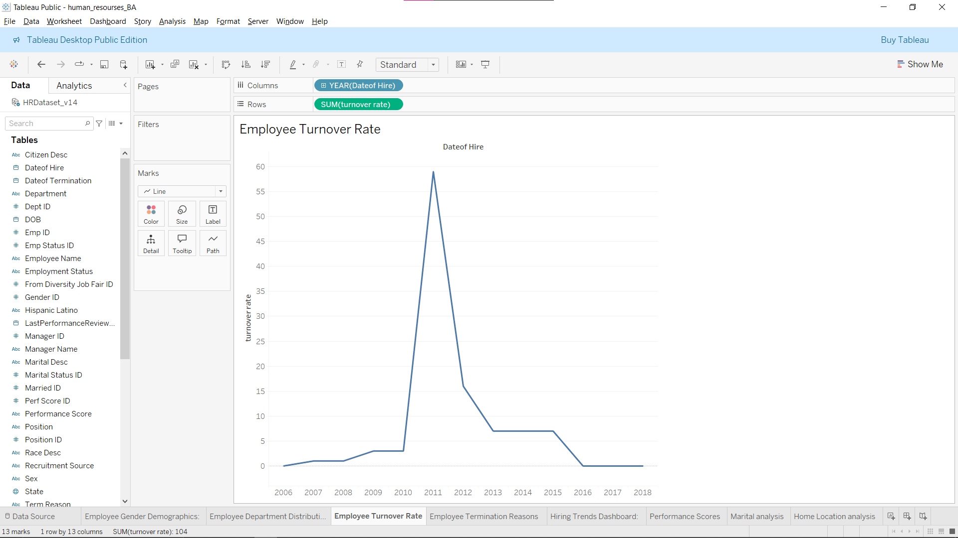

* **Marital Status**:  
  A bar chart was used to display the marital status distribution of employees, offering insights into how many employees are married, single, or other marital statuses. This information can help identify any potential trends or patterns within the workforce.

Screenshot of Marital Status Bar Chart

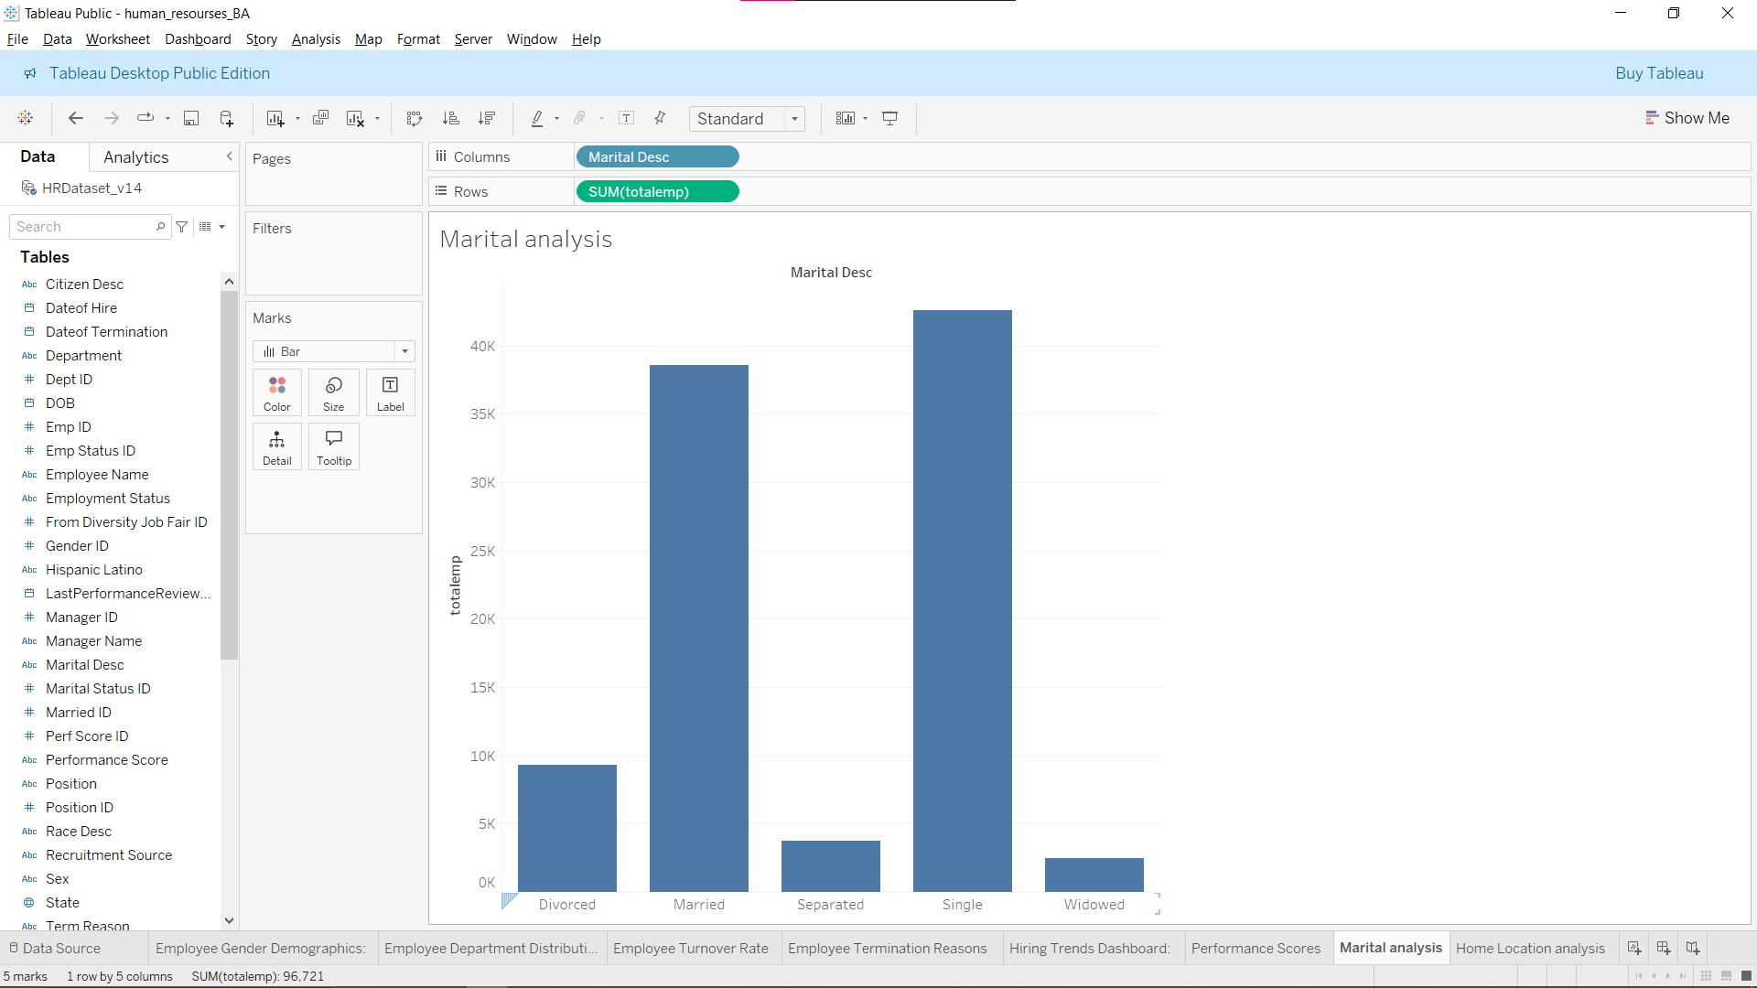

* **Home Location**:  
  A pie chart was created to show the distribution of employee home locations. This can help identify the geographic diversity of the workforce, and potential areas to target for recruitment or engagement.

Screenshot of Home Location Pie Chart  
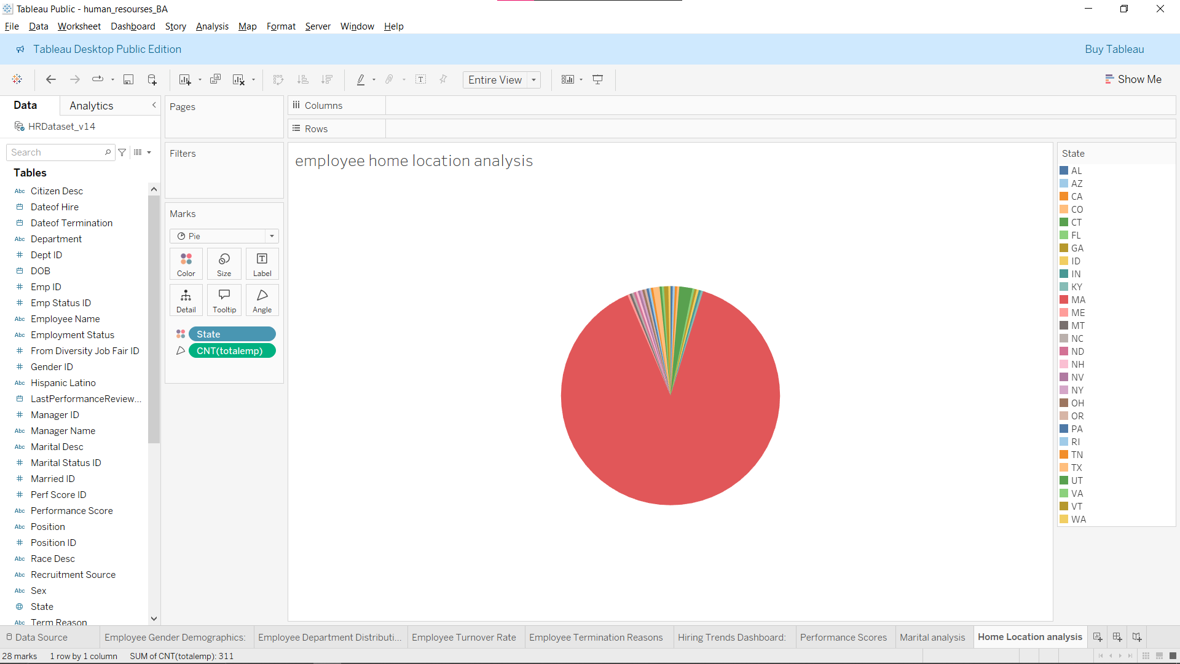

* Termination Reasons:  
  A bar chart illustrates the reasons for employee terminations. This analysis can help HR teams understand common causes and address potential issues in employee retention.

*Screenshot of Termination Reasons Bar Chart*  
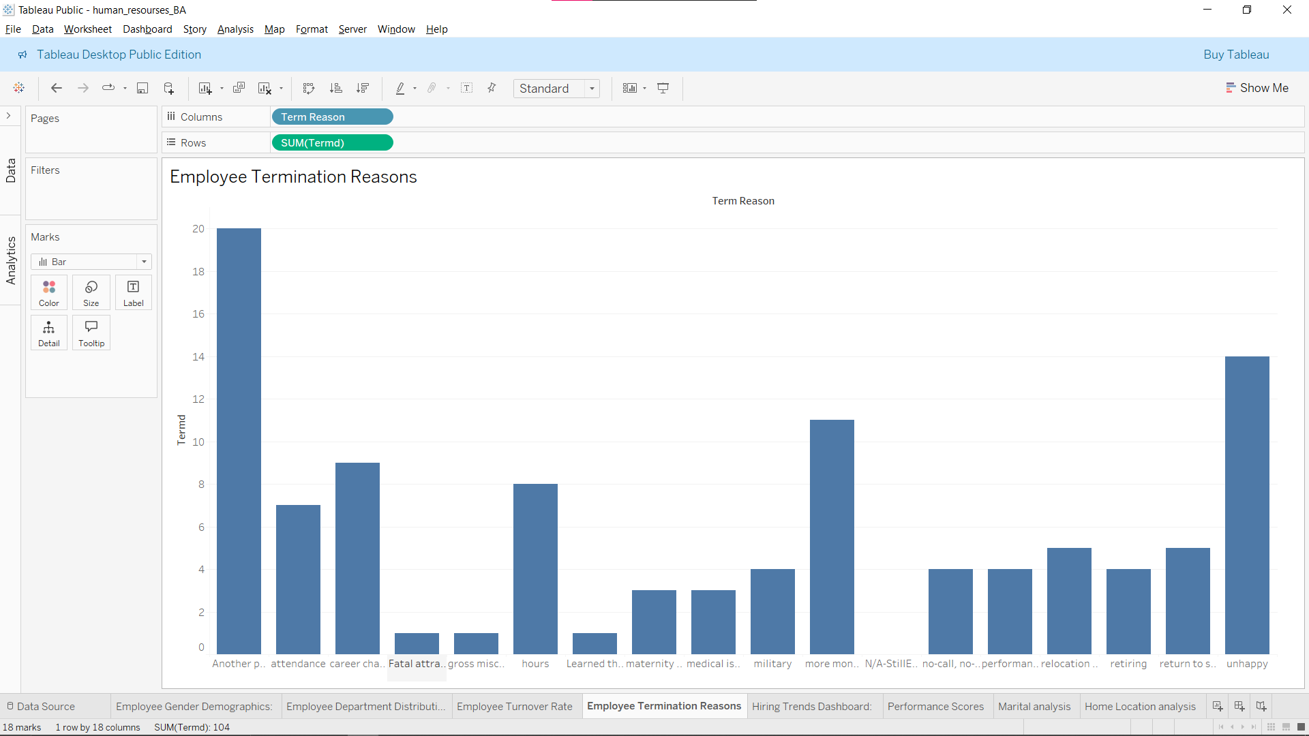

**3.3 Hiring Trends**

* Hiring Rate:  
  A line chart was used to show the rate at which new employees are being hired over time. This allows for analysis of hiring patterns.

*Screenshot of Hiring Rate Line Chart*  
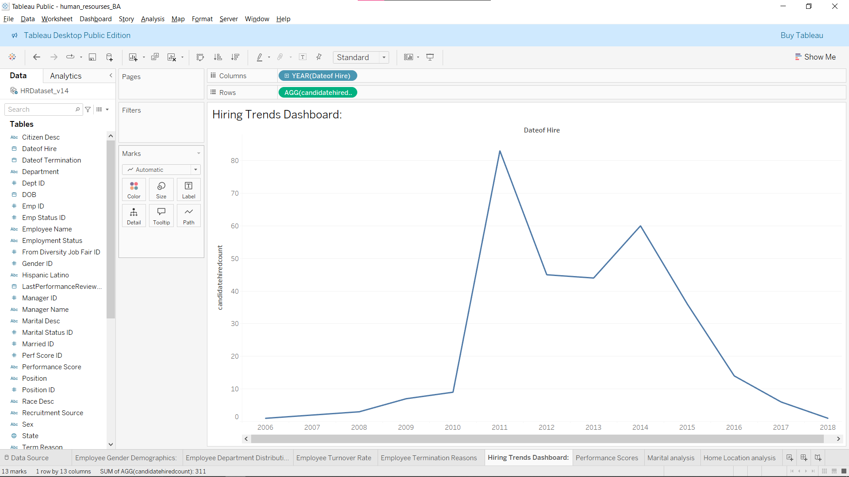

* Source of Hire:  
  A bar chart illustrates where new hires are sourced from (e.g., internal referrals, job boards, recruitment agencies). This can guide future recruitment strategies.
* Time to Fill:  
  A bar chart was used to show the average time to fill positions in different departments or job roles.

**3.4 Performance Metrics**

* Performance Scores:  
  A scatter plot was created to display the performance scores of employees, enabling the identification of high-performing and low-performing individuals.

*Screenshot of Performance Scores Scatter Plot*  
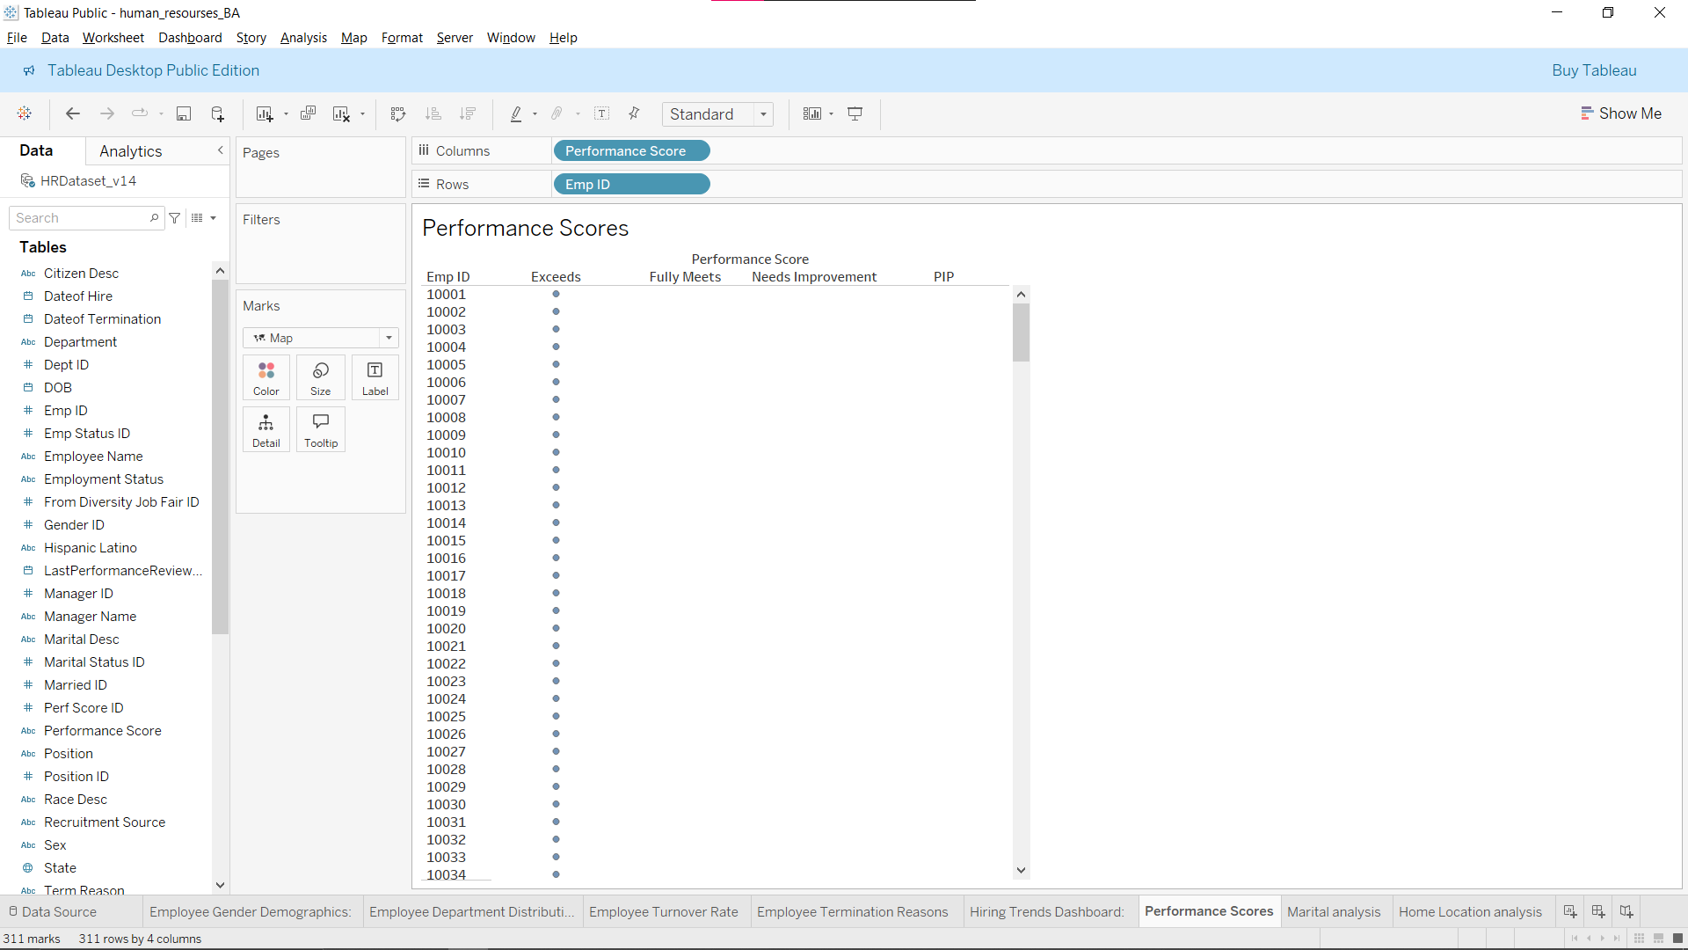

* Top Performers:  
  A leaderboard was generated to highlight the top-performing employees. This can be useful for recognizing achievements and motivating employees.

**4. Key Insights**

The visualizations reveal several important insights:

* Employee Demographics: The age distribution shows that the company has a predominantly young workforce. Gender balance is fairly even, although there may be room for improvement in certain departments.
* Employee Turnover: There are seasonal spikes in turnover, with the highest turnover rate observed in Q2. The most common termination reasons are resignation and personal reasons, which can inform retention strategies.
* Hiring Trends: Hiring has been steady, but the average time to fill positions is longer in certain departments. Additionally, most hires come from internal referrals and online job postings.
* Performance Metrics: Top performers consistently rank high across various metrics, and it’s clear which employees need additional training or support based on their performance scores**.**

**5. Conclusion**

This analysis provides valuable insights into the organization's workforce dynamics. By closely monitoring these HR metrics, the company can improve employee retention, optimize hiring processes, and better understand employee performance. The visualizations not only present data in an easily digestible format but also enable HR teams to make data-driven decisions.

Future improvements to this analysis could include incorporating employee satisfaction surveys, feedback loops, and more granular demographic data to further refine the insights.